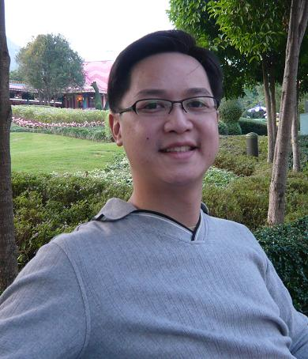

書名：Approaches and Principles of Teaching English in Taiwan

著者：周則銘

______________________________________________________________________

發行人/蘇慧莉

出版社/翠柏林企業股份有限公司

出版社/高雄市三民區立志街75巷10-1號

電話/07-6011546 07-3837708

傳真/07-6011572 07-3897236

登記證/局版台業字第599號

出版日期/中華民國101年 9 月

經銷商/建工書局

地址/高雄市三民區建工路472號

電話：07-3837708

傳真：07-3897236

定價元: 300

______________________________________________________________________

Dr. Peter Tze-Ming Chou is currently an Assistant Professor at Wenzao Ursuline College of Languages. Dr. Chou received his Ph.d in Curriculum and Instruction from Indiana State University in Terre Haute, IN, USA.

**Approaches and Principles of Teaching English in Taiwan**





By

Dr. Peter Tze-Ming Chou

翠柏林出版

◎本書有著作權，任何人未獲書面授權，不得以翻印、轉載、影印、照像、錄製等任何方式利用本書部分或全部內容，否則依法追究。

ISBN: 978-986-8 7831-9-5