目錄

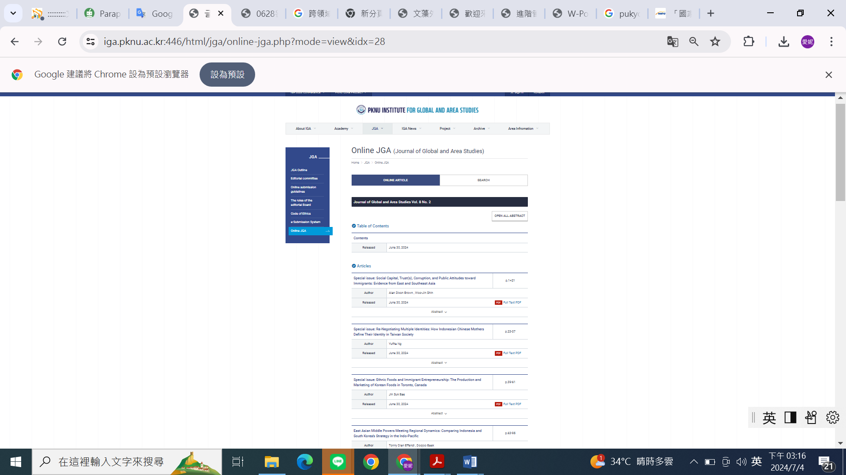

Link:

https://iga.pknu.ac.kr:446/html/jga/online-jga.php?mode=view&idx=28