封面

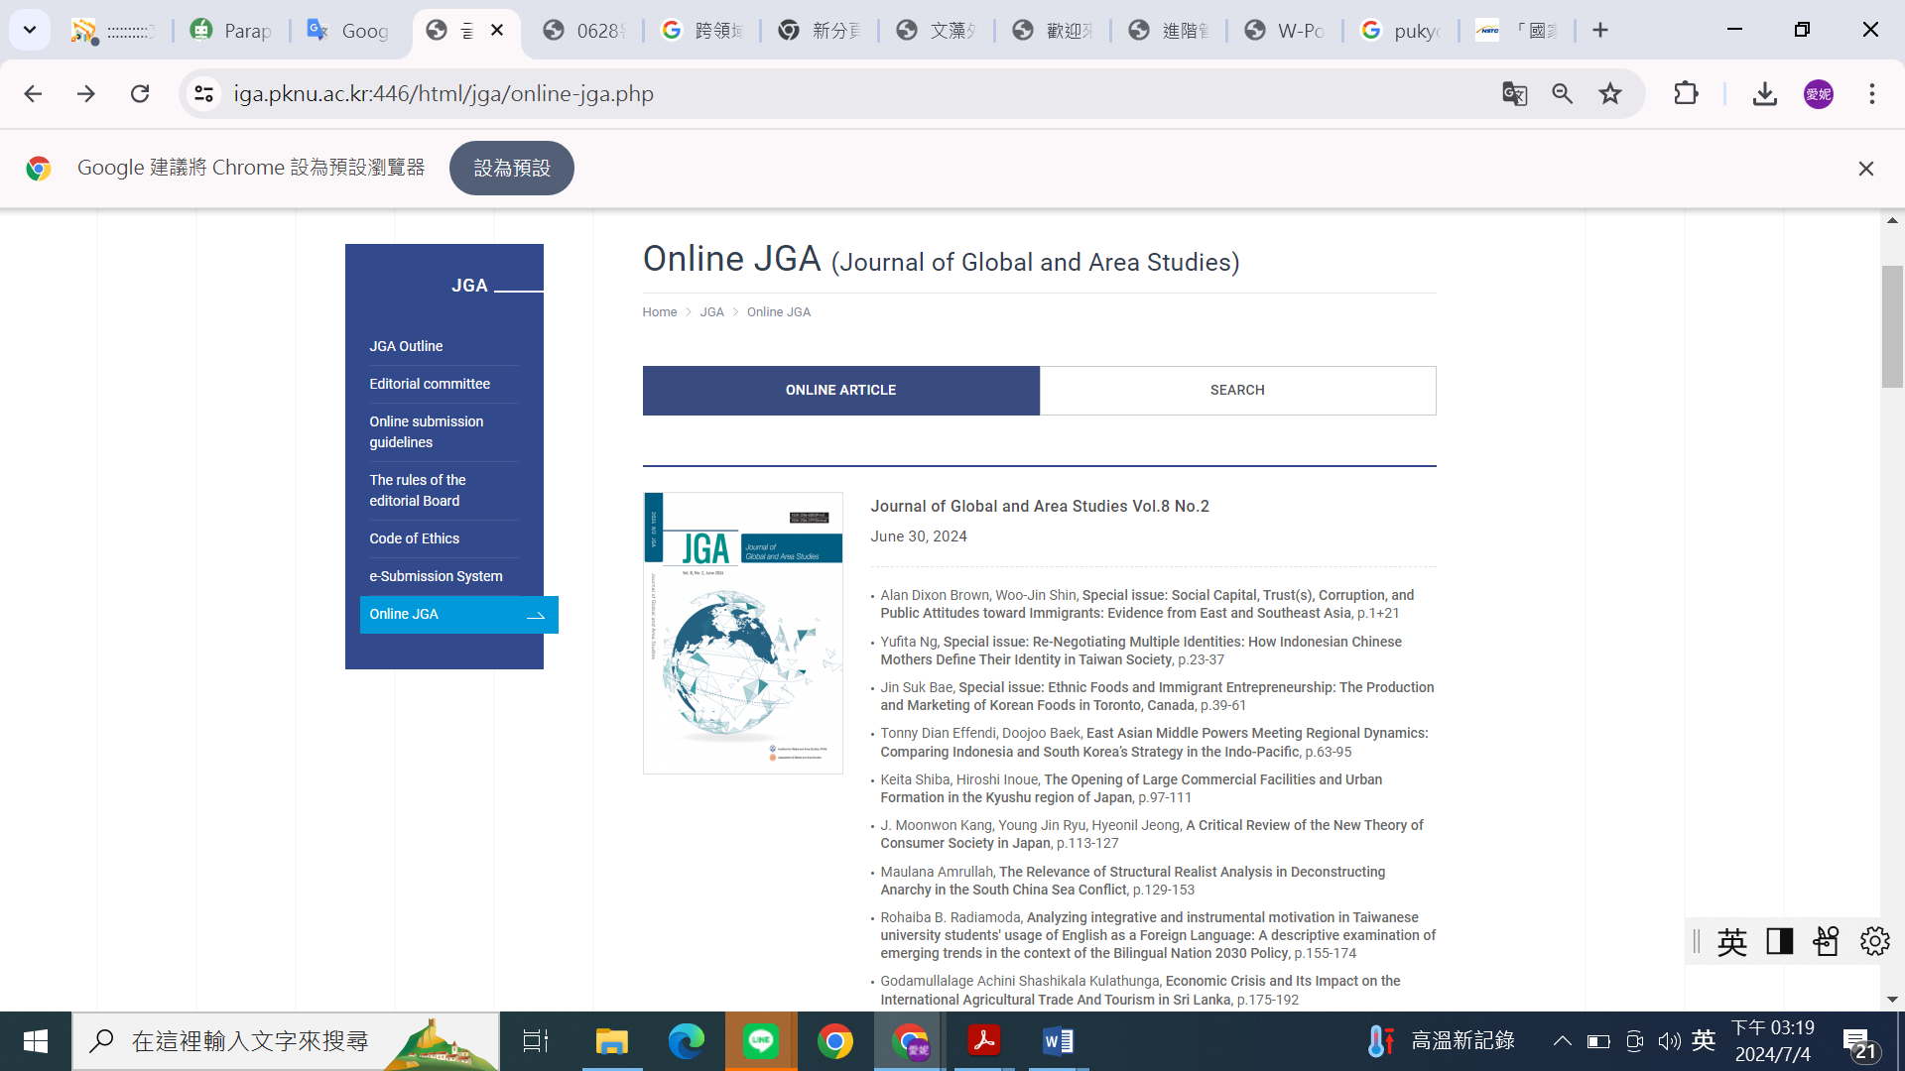

Link:

https://iga.pknu.ac.kr:446/html/jga/online-jga.php