第二屆全國「大學英文」學術研討會

舉辦地點: 國立政治大學
舉辦日期: 2008年3月29日

Situated Pedagogy:
Culture Learning and College Fresh Person English
Sandie Yi Jou Luo
Assistant Professor
Department of English
Leader University
Abstract
Despite Schwab (1954) in the twentieth century shocked the world by a paper titled as “Is Freshman English Obsolete”, he proclaimed an English class still a necessity but grammar teaching and vocabulary pouring be outmoded and should be superseded. Indeed, when it comes to the pedagogy for the twenty-first century, it is easily concluded that culture learning should be the vogue. As a matter of fact, the affiliation between culture learning and language pedagogy has also been proposed for years (Brook, 1997; Lafayette, 1976; Sadow, 1987; Seelye 1984). In the mean time, Gortazzi and Jin (1995) notified that to inculcate knowledge of target cultures to foreign language learners, using textbooks should be one of the most applicable ways. As a result, this paper intends to present a culture-oriented teaching plan in College English for Fresh Persons (CEFP) based on a textbook, Reason to write: Strategies for success in academic writing. Be it entitled with “writing”, Reason to write is also a felicitous textbook for reading by proffering culture agendas (such as slavery, verdict dilemma and gender issues) in class. In pedagogy, I will apply Moran’s four categories (2001:15-18) of culture teaching—from Knowing About, Knowing How, Knowing Why to Knowing Oneself—to develop teaching plans from Reason to write. This paper ends to reinforce the applicability, practicality, and the necessity of culture learning in CEFP.

Key words: College Learning, College English for Fresh Person (CEFP), Knowing About, Knowing How, Knowing Why, Knowing Oneself

Introduction
Schwab (1954) in the twentieth century shocked the world by a paper titled as “Is Freshman English Obsolete” in which he questioned the continuous practicability of Freshman English since English teachers are busy “getting angry” with students while students may “have the urge to shoot their English instructors” (p.82) because of the boring class. However, Schwab in the long run went back to the traditional route to claim for the effect of Fresh Person English with “good” contents. According to Schwab, good contents are those which are away from didactic grammar teaching and vocabulary pouring--both of the previous two pedagogical methods should be outmoded and be superseded to Schwab. In fact, when it comes to the pedagogy for the twenty-first century, it is easily concluded that culture learning should be the vogue. Dwelling in such a global village, one may be situated in confronting people from different cultural background in a different language. Thus, the affiliation between culture learning and language pedagogy has been proposed for years (Brook, 1997; Lafayette, 1976; Sadow, 1987; Seelye 1984). Combining with Schwab’s opinion, thus, I hereby propose a culture-orientation as the contents in college English pedagogy. In the mean time, good tools are always a requirement for an efficient method. Cortazzi and Jin (1995) notified that to inculcate knowledge of target cultures to foreign language learners, using textbooks should be one of the most applicable ways. As a result, this paper intends to present a culture-oriented teaching plan in College English for Fresh Persons (CEFP) based on a textbook, Reason to write: Strategies for success in academic writing. Be it entitled with “writing”, Reason to write is a felicitous textbook for reading and speaking by proffering culture agendas (such as slavery, verdict dilemma and gender issues) in class. Culture orientation ultimately aims at a clear self-awareness. In pedagogy, henceforward, I apply Moran’s (2001:15-18) four categories of culture teaching—from Knowing About, Knowing How, Knowing Why to Knowing Oneself—to develop a teaching plan from Reason to write. This paper ends to reinforce the applicability, practicality, and the necessity of culture learning in CEFP.
Definitions of Key Terms
Definitions of the key terms in this paper are given as follow to avoid confusion:
1. Situated Pedagogy
The term is coined by myself with the inspiration from Dona Haraway’s (1988) “situated knowledge” in which Haraway claimed a new idea of the praticability of knowledge. In brief, the traditional conception of the “true” essence of knowledge should be overthrown and be replaced by situated knowledge in which it is the interaction among people or events that my put influence on the learning and obtaining of knowledge.
In this paper however, “situated pedagogy” is a response to Schwab’s question on Fresh-person English. Schwab proclaimed contents orientation in pedagogy while I would proffer situation-orientation as the replacement. It is the situation students will or have to confront with that may trigger their learning motivation. In this article, I refer to culture as one of the situations students may encounter. Consequently, applying different cultural situations in pedagogy, I name it as situated pedagogy.
2. Culture
According to Lin (2005), culture can be referred to (1) membership in a social group with common goals, purposes, and language; (2) the social group itself; (3) the standard system. However, Moran’s definition (2001) is much more appropriate in this paper. He defined culture as “he evolving way of life of a group of persons, consisting of a shared set of practices associated with a shared set of products, based upon a shared set of perspectives on the world, and set within specific social contexts” (p.24). Briefly speaking, Moran referred to culture as being dynamic rather than static. The word “Situated” of the title of this paper also suggests a dynamic pedagogical method.
3. Moran’s Four Categories of Culture Teaching
Moran’s Teaching culture: Perspectives in practice (2001: 15-18) offered four categories of culture teaching from Knowing About, Knowing Why, Knowing How to Knowing Oneself. The Four Knows also demonstrate the development of a learner from knowledge obtaining, understanding, practicing to awareness. Learners consequently are not inert but active. They are asked to describe, interpret, participate in and finally reply to what they have received, accepted, and learned in class. Teachers are encountering of the changing roles as well. At least they should be information providers, content/process-facilitators, designers to counselors.
Figure 1.: Four categories of culture teaching.
Adapted and Taken from Moran (2001)
Knowing Oneself  Student role: responses question finder and answer  Activities: reflection  Outcome: self awareness  Teacher role: counselors. |  | Knowing About  Student role: description  Activities: gathering information  Outcome: cultural knowledge  Teacher role: information providers
 | Four categories of culture teaching.
Knowing How  Student role: participations  Activities: developing skills  Outcome: cultural behaviors  Teacher role: designers |  | Knowing Why  Student role: interpretation  Activities: discovering explanations  Outcome: cultural understanding  Teacher role: content/process -facilitators
Teaching Culture and Its Application
During the last decades, there have been a large number of articles, papers and/or books regarding culture teaching, and its importance and application in language pedagogy (Cortazzi and Jin, 1999; Hinkel, 1999; Harrison, 1990; Kramsch, 1998; Moran, 2001; Stern, 1992; Spencer-Oatey, 2000). Benefits of culture teaching include (1) helping learners relate the abstract sounds and forms of a language to real people and places (Chastain, 1971); (2) providing a more communicative approach than a more grammatically based approach (Higgs, 1984; Omaggio, 1985; Rivers, 1981); (3) helping learners the ability “to see another perspective challenges rigid stereotypes and contributes to an appreciation of individual differences.” (Sleeter, 1991: 168); (4) studying culture we also learn about geography, history of the target culture (Cooke, 1970).
Following the trend, many cultural-oriented teaching books are published and Reason to write: Strategies for success in academic writing (intermediate) is one of them. This theme-based book, though being complied as a writing textbook, can be applied into a culture-based reading course. First of all, the ten units apparently concern about different aspects of the American cultures. Unit One focuses on paragraphs from F. Douglass, a famous American pre-slave whose autobiography especially catches the world’s eye since he represents the best example of a self-made man from rags to riches. Unit Two cites a piece of news with the concerning of the prosecution system in America. After ethnocity and law (legitimation?), Unit Three brings learners on gender differentiation. Unit Four, “The Best Time to Be Alive”, actually, is the best example on culture pedagogy with the focus on Chinese and Japanese history and culture. Unit Five illustrates Summerhill, an inventive approach to education; Unit Six talks on the sleeping problem; Unit Seven, “How I’ll Become an American”, is the life a Hungarian in America; Unit Eight goes back to education again with the emphasis on the issue of bilingual education; Unit Nine is a case study on Business Ethics in America; the last unit presents learners the short story of Poe, “The Tell-Tale Heart”. All in all, from ethnocity, race, gender, education, business, and even to literature, Reason to write obviously intends to manifest a panorama of America.
Chart 1. Contents and themes of units in Reason to write
Unit | Title | Contents | Classification
Unit One | The Pathway to Freedom | Paragraphs from F. Douglass, a famous American pre-slave. | Ethics
Unit Two | What’s Your Verdict? | a piece of news with the concerning of the prosecution system in America. | Law
Unit Three | Men and Women: Nothing but the Facts | Show survey on the differences between boys’ and girls’ opinion. | Gender
Unit Four | The Best time to be Alive | Discussion on different cultures with the focus on Japanese and Chinese culture. | Cross Culture
Unit Five | The Happiest School in the World | Illustrate Summerhill, an inventive approach to education | Education
Unit Six | Are You Getting Enough Sleep? | Talks on the sleeping problem | Psychology
Unit Seven | How I’ll Become an American? | The life of a Hungarian in America. | Cross-culture
Unit Eight | For and Against Bilingual Education | The issue of bilingual education | Education
Unit Nine | Case Studies in Business Ethics: Malden Mills and Ben & Jerry’s Ice Cream | Business Ethics in America; | Business ethics
Unit Ten | The Tell-Tale Heart | A short story of Poe | Literature
Due to the limitation of this paper, I will only select one unit, Unit One, in the application with the light of Moran’s four culture teaching methods.
Unit One The Path to Freedom
The reading of this unit is an excerpt from F. Douglass’s Narrative of the life of Frederick Douglass. Slavery and its affiliating issues have occupied the construction and establishment of America. In Asia, the same issue is less highlighted because it is always categorized into the issue of hierarchy while in America, it is more complicated with race involved. Based on Moran’s four categories, the teaching procedure is depicted as follows,
I. Knowing About
In the Warm up stage, the unit provides a picture with a black woman slave and a white girl. The teacher can ask students to describe what they see. The teacher can also provide more photos, news, illustrations, report on slavery. Especially, the teacher can provide an illustration, “Slave with Iron Muzzle” made in 1839 and a photo of a dog with muzzle as a contrast.
The teacher can start by asking questions as
In Figure 3
1. Why do you think is the man (in figure 3) wearing an iron muzzle?
2. Is there any possible that one may want to wear an iron muzzle?
3. What might the man feel with the muzzle on?
Figure 3 and 4
1. Make a comparison between figure 3 and figure 4.
Figure 5.
1. What are the two pieces of news about?
2. In particular, what can be sold in figure 6? Anything unusual?

Figure 2. Comparison of the two females (Cohen & Miller, p.1, 2003) | Figure 3. Slave with iron muzzle (Artist Unknown, 1839) | Figure 4. A Dog with a muzzle (Leerburg, 2008)
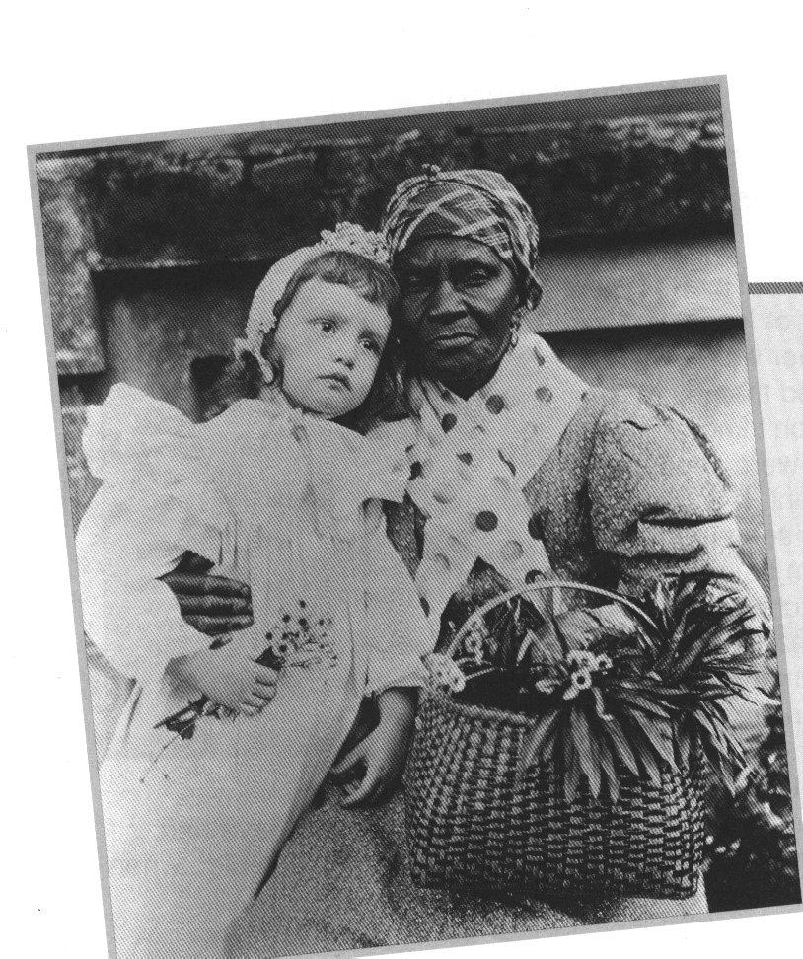 | 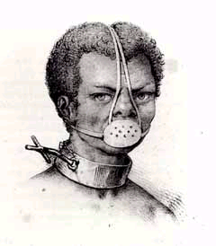 | 

Figure 5. Apiece of newspaper shoed slaves could be sold and let
(Wilberforce House Museum, 2008)
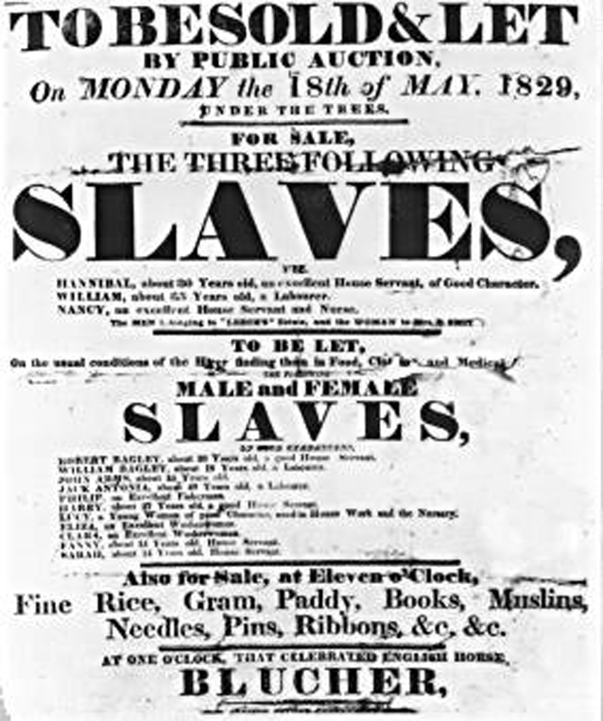

II. Knowing Why
Students at this time should learn to interpret. After reviewing the illustrations, the teacher reads with students the text. In terms of questions provided by the textbook and the teacher, students may discover differences of slavery in America and Chinese.
Again, the teacher can facilitate students’ understanding by asking some content-questions,
- Why did Douglass want to die?
- What made him change his mind?
- What were your feelings when you read Douglass’s writing?

III. Knowing How
To enhance students’ speaking ability,
1) Students may organize some mini-plays to present situations Afro-Americans used to encounter with.
2) Students may have a debate on the correlation between freedom and education, or the desire to eat and the desire to learn.
To motivate students’ reading interest,
1) The teacher can arrange a Reader Theater on the text. In a Reader Theater script, it is the reading that is the focal point. Learners can read articles by paying attention to the intonation but not by memorizing words. Thus, learners will not be too much afraid of reading. This kind of teaching strategy is said to be effective in students’ decoding and word recognition skills (Martinez, Roser & Strecketer, 1999; Rasinski, 2003) and furthermore, in improving students’ reading comprehension (Martinz, Roser & Strecker, 1999; Wrothy & Prater, 2002; Rasinski, 2003).
To enhance students’ writing ability,
1) students can also compose posters to proclaim the abolition of slavery.
In this way, students are improved in the four English skills.

IV. Knowing Oneself
The last phase is designed to make sure if students have learned.
- The teacher can ask students a self-assessment of a Know-Thyself Chart as follow in Chart 2. Chart 3. provide examples from a student in my class with grammar modification.
Chart 2. Know Thyself
What I knew about slavery | What I know about slavery | What I have learned

Chart 3. Know Thyself-Students Response
What I knew about slavery | What I know about slavery | What I have learned
I knew slavery from POWs either in video games or in the real wars. I knew it must have been horrible to be in that condition. One would definitely be tortured even to death. | A slave needs to work hard. They may suffer from hunger and many other tortures. However, being deprived of freedom definitely is the worst one. | I am surprised to know (1) the slave holder could seize their slaves back; (2) the one who helped the slave would be fined; (3) the importance of education. In the beginning, I did not understand why Douglass exchanged knowledge with bread from some white boys. However, after learning more of his achievement, I think he is right to make the choice.
Teacher’s comment | Teacher’s comment | Teacher’s comment
Generally, POW in fact is a prisoner but a slave. There are still differences. | How about education? Have you noticed Douglass emphasized a lot on education as well? | (Unless students show incorrect morality deviation, it’s better to leave a blank in this item to show respect and even cherish of students’ independent thinking.
2) The teacher can support with more information such as Fugitive Act in 1850. The teacher then may ask students’ related opinions about the act such as (i) is it right for a slave to run and (ii) is it appropriate for a slave owner to catch back slaves?
- Students can be separated into several groups and list the reasons why slave owners had to keep slaves and why slaves thought it unfair. Then, have groups to talk about their own reasons and check if there are any similar ideas and why?
- Further questions can be raised in class (cited from Reason to write, p.20)
i) Have you ever experienced a lack of freedom? Describe this experience, how it felt and whether you were able to change it.
ii) Have you ever experienced prejudice? Write about your experience or your thoughts about prejudice directed against race, religion, nationality, or gender.
“Situated Pedagogy” is planned to teach without or little restriction on students’ conception as possible. It is a pedagogical method to ask for reactions to different situations. As a result, when teaching a unit on racial discrimination like this unit, the teacher still needs to avoid partiality. That is why in Knowing Oneself, the teacher designs questions and/or situations to help students to think as in the slave owner’s shoes.
V. Extension
If time is allowable, the teacher can introduce more works on slavery or even movies as Toni Morrison’s Beloved and Alice Walker’s Color Purple as a comparison to know more about men and women slaves.
Suggestion and Conclusion
Despite the multiple topics for discussion, Reason to write may have a bias on its American-cultured contents. All of the units in fact are closely associated with American life and culture. Hence, I do suggest, (1) a selective unit which means the teacher can also have some other options from other textbooks; (2) more information provided with the focus on other cultures as the comparison. All in all, to avoid an American-culture-worshipping, the teacher needs to pay more attention in his/her pedagogy and unit selection.
Yet, to sum up, in the introduction, Cohen and Miller (2003) indicated the textbook of Reason to write aims at the encouragement of a critical thinking. Thus, they provide analytical skills, and theme based contents with “provocative reading passages” (p.v) to develop “independent writers” (p.vi). From the previous lesson plan, I wish to prove the practicability of applying this textbook in reading pedagogy. From the previous lesson plan, the four teaching categories also help to frame or develop students’ learning steps. From Knowing About, students learn to describe what they see and read; Knowing What, students learn to read between the line (to interpret); Knowing How, students participate in activities and thus they are encouraged to apply what they learn in designed activities; the last phase, Knowing Oneself, is set up for students’ mental growth. All in all, from unknowing to knowing, the four categories of Moran with culture as the contents and learning objectives but without the cramming of difficult vocabulary and grammars, the lecturers and students will not hate each other. Fresh persons will not feel bored but fresh in CEFP.

References
Brooks, N. (1997). Teaching culture in the foreign language classroom. In Heusinkveld, P.R. (Ed.) Pathways to culture. (pp.11-37) Yarmouth, ME: Intercultural Press.
Chastain, K. (1971). The development of modern language skills: Theory to practice. Philadelphia: The Center for Curriculum Development, Inc.
Cohen, R. F. and Miller, J. L. (2003). Reason to write: Strategies for success in academic writing (intermediate). New York and England: Oxford University Press.
Cooke, M. A. (1970). Suggestions for developing more positive attitude toward native speakers of Spanish. In H. N. Seelye. (Ed.) Perspectives for teachers of Latin American culture. Springfield, IL: State Department of Public Instruction.
Cortazzi, M., & Jin, L. (1995). Culture: Hidden resources in the English language classroom. Proceedings of the Fourth International Symposium on English Teaching (pp. 204-220). Taipei, Taiwan: Crane.
Cortazzi, M. and Jin, L. (1999). Cultural mirrors: Materials and methods in the EFL classroom. In E. Hinkel (Eds.) Culture in Second Language Teaching and Learning. (pp. 196 – 220) Cambridge: Cambridge University Press.
Haraway, D. (1991). Situated knowledge: the science question in feminism and the privilege of partial perspective." Feminist studies 14, pp.575-99.
Harrison, B. (1990). Culture and the language classroom. Hong Kong: Modern English Publications in association with The British Council.
Higgs, T. (Ed.). (1984). Teaching for proficiency, the organizing principle. Lincolnwood, IL: National Textbook Company.
Hinkel, E. (1999). Culture in second language teaching and learning. Cambridge: Cambridge University Press.
Kramsch, C. (1998). Language and culture. Oxford: Oxford University Press.
Lafayette, R. (Ed.). (1976). The culture revolution in foreign language teaching. Stokie, IL: National Textbook Company.
Leerburg video & kennel. (2008). Muzzle sizes. Leerburg 2008 catalogue. Retrieved 2008/03/31 from http://leerburg.com/muzzlefit.htm.
Moran, P. (2001). Teaching culture: Perspectives in practice. Boston, MA: Heinle & Heinle.
Lin, Y. H. (2005). A Study on Integration of Culture into a College General English Reading and Writing Class. Unpublished master’s thesis. Southern Taiwan University, Tainan, Taiwan.
Martinez, M., N. L. Roser, and S. Strecker. “I never thought I could be a Star:’ A Readers Theatre ticket to fluency.” The Reading teacher, 52:4 (December 1998/ January 1999): 326–334.
Omaggio, A. C. (1986). Teaching language in context: Proficiency-oriented instruction. Boston,. MA: Heinle & Heinle Publishers, Inc.
Rasinski, T. V. (2003). The fluent reader: Oral reading strategies for building word recognition, fluency, and comprehension. New York: Scholastic professional book.
Rivers, W. (1981). Teaching foreign language skills (2nd ed.). Chicago: University of Chicago Press.
Sadow, S. A. (1987). Speaking and listening: imaginative activities for the language class. In W. M. Rivers (Ed.), Interactive language teaching (pp.33-43). Stern. H. (1992). The Cultural Syllabus in Stern, H. (1992) Issues and options in language teaching. (pp. 205-242) Oxford: Oxford University Press
Schwab, W. (1954) Is Freshman English obsolete?: The answer depends on the content of instruction. The journal of higher education, Vol. 25, No. 2. pp. 82-88.
Seelye, H. (1984). Teaching culture: Strategies for intercultural communication. Illinois: National Textbook Company.
Sebok, A. J. (1991). Judging the Fugitive Slave Acts. The Yale Law Journal, Vol. 100, No. 6, pp. 1835-1854.
Slave with Iron Muzzle. (1839). University of the poor. Retrieve 2008/03/30 from http://www.universityofthepoor.org/schools/artists/abolition/ironmuzz.htm.
Sleeter, C. E. (1991). Empowerment through multicultural education. New York: State University of New York Press, 1991.
Spencer-Oatey, H. (2000). Culturally speaking: Managing rapport through talk across cultures. London: Continuum.
Stern. H. (1992). The Cultural Syllabus. in Stern, H. (1992) Issues and Options in Language Teaching. (pp. 205-242). Oxford: Oxford University Press
To be sold and let. (2008). Wilberforce House Museum. Retrieve 2008/03/31 from http://www.bridgemanartondemand.com/index.cfm?event=catalogue.productGroup&groupKey=whm
Worthy J., & Prater K. (2002). The intermediate grade-“I thought about it all night”: Readers Theatre for reading fluency and motivation. The Reading Teacher, 56(3), 294-297.

作者
羅宜柔
立德管理學院助理教授
０９２３１２６１２７
鳳山善美路３３號

Fugitive Act in 1850 is a strict act for slave and runaway. Especially, to restrict those who are for the slaves, many regulations were established to ask a fine for those who help runaway. See Sebok’s Judging the Fugitive Slave Acts. The Yale Law Journal, Vol. 100, No. 6, pp. 1835-1854.

