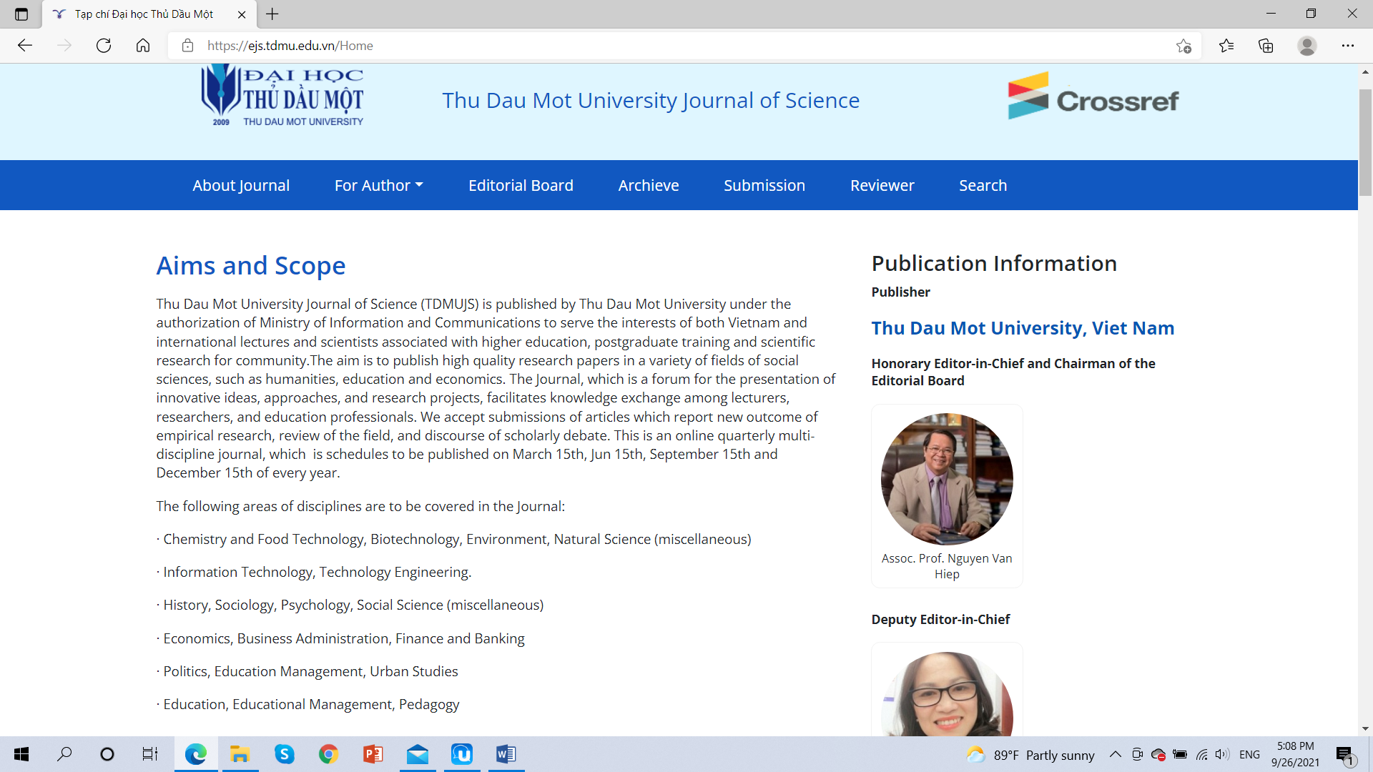

Thu Dau Mot University Journal of Science

Tạp chí Đại học Thủ Dầu Một https://ejs.tdmu.edu.vn



**Aims and Scope**

Thu Dau Mot University Journal of Science (TDMUJS) is published by Thu Dau Mot University under the authorization of Ministry of Information and Communications to serve the interests of both Vietnam and international lectures and scientists associated with higher education, postgraduate training and scientific research for community. The aim is to publish high quality research papers in a variety of fields of social sciences, such as humanities, education and economics. The Journal, which is a forum for the presentation of innovative ideas, approaches, and research projects, facilitates knowledge exchange among lecturers, researchers, and education professionals. We accept submissions of articles which report new outcome of empirical research, review of the field, and discourse of scholarly debate. This is an online quarterly multi-discipline journal, which schedules to be published on March 15th, Jun 15th, September 15th and December 15th of every year.

The following areas of disciplines are to be covered in the Journal:

∙ Chemistry and Food Technology, Biotechnology, Environment, Natural Science (miscellaneous)

∙ Information Technology, Technology Engineering.

∙ History, Sociology, Psychology, Social Science (miscellaneous)

∙ Economics, Business Administration, Finance and Banking

∙ Politics, Education Management, Urban Studies

∙ Education, Educational Management, Pedagogy

**Publisher**

**Thu Dau Mot University, Viet Nam**

# Editorial Review Board

Editorial Board of Thu Dau Mot University Journal of Science is a open science research organization dedicated to promoting the advancement of science, engineering and technology. Membership is free of charge, and members are actively encouraged to engage in open science scholarly research collaboration and communication.

Members must hold the academic rank of Ph.D. or equivalent in order to participate in editorial review boards. Becoming a member serving on editorial review boards grows your institution’s research exposure, and allows researchers to collaborate and publish scholarly content in open science. Membership allows for wider dissemination of scholarly knowledge and increases the potential for downloads and citations.

Open Science originates with the premise that universal scientific knowledge is a product of a collective scholarly and social collaboration involving all stakeholders and knowledge belongs to the global society. Scientific outputs generated by public research are a public good that should be available to all at no cost and without barriers or restrictions. The editorial review boards embrace the philosophical principle of open science’s universality, freedom, and responsibility.

**Honorary Editor-in-Chief and Chairman of the Editorial Board** Assoc. Prof. Nguyen Van Hiep

**Deputy Editor-in-Chief** PhD. Trần Hạnh Minh Phương Thu Dau Mot University

**Editorial Board:**

Prof. Tran Van Doan Fujen University, Taiwan

Prof. Zafar Uddin Ahmed Vietnam National University Ho Chi Minh City

Prof.Dr. Phillip G.Cerny The University of Manchester, United Kingdom

Prof. Ngo Van Le University of Social Sciences and Humanities (VNU-HCM)

Prof. Bui The Cuong Southern Institute of Social Sciences​​​​​​​

Prof. Le Quang Tri Can Tho University

Assoc. Prof. Nguyen Van Duc Animal Husbandry Association of Vietnam

Assoc. Prof. Ted Yuchung Liu National Pingtung University, Taiwan

PhD. Anita Doraisami Economics Monash University, Australia

Prof. Dr. Andrew Seddon Asia Pacific University of Technology & innovation (APU)

Assoc. Prof. Le Tuan Anh Thu Dau Mot University

Prof. Abtar Darshan Singh Asia Pacific University, Malaysia

Prof.Dr. Ron W.Edwards The University of Melbourne, Australia

Assoc. Prof. Hoang Xuan Nien Thu Dau Mot University

PhD. Nguyen Duc Nghia Vietnam National University Ho Chi Minh City

PhD. Bao Dat Monash University (Australia)

PhD. Raqib Chowdhury Monash University (Australia)

PhD. Nguyen Hoang Tuan Thu Dau Mot University

PhD. Nguyen Thi Lien Thuong Thu Dau Mot University

Nguyen Thi Man Thu Dau Mot University